Hannah Wilson

ANTH 5244 Capstone

Professor Tappen

2 May 2022

Taphonomic Exploration of Dmanisi: Analysis of Oblique Break Angles

**Background**

The prehistoric site at Dmanisi, Georgia is the subject of many research projects that seek to understand its taphonomy. Because of its content, size, and potential to provide context to hominin lifestyles, it is an important piece in the puzzle of human evolution. The site at Dmanisi offers a unique view into the ecology and climate surrounding early hominins: understanding its overall composition in a statistical manner can yield further information on the interactions that led to this specific accumulation.

Dmanisi is found at the confluence of two rivers in the Mashavera River Valley region of Georgia. It was first discovered as a medieval site with several cellars found. These medieval cellars were dug into the earlier prehistoric site, and since, the prehistoric site has contributed unprecedented information to the study of hominins. Within the site, there are several excavation blocks that contribute to research. Block 2 provides the greatest number of specimens in total, so it has been the subject of several spatial analysis efforts (Coil et al., 2020; Figure 1, Index B).

The site provided five hominin skulls so far, but it also has a very large assemblage of other mammalian remains. One of the most compelling aspects of the site is the wide variety of taxa represented in the identified samples (Figure 2, Index B). According to Bartolini-Lucenti et al. (2022), “apart from the remarkable record of hominins, the site of Dmanisi has yielded a rich and diverse fossil coenosis with up to 54 vertebrate taxa, among which 45 belong to Mammalia.” The presence of these many mammal types is uncommon in most other sites of the same period, as is the number of hominin remains found. Due to the proximity of the hominin and mammal remains, they have the potential to reveal interesting information about each other: most importantly to research of human evolution, the mammal specimens provide an opportunity to explore the pale-environment surrounding early hominins.

Some previous research examined the possible ecology of Dmanisi, and saw that “the evidence from Dmanisi supports the interpretation of the patchy environments of both deciduous forests and open areas, with relatively dry climate, warmer, and drier than today and similar to the present Mediterranean type” (Bartolini-Lucenti et al., 2022). The climate described here meant that there were many habitats located in a relatively small area, which may be the reason that many different species are found at the site – resources for many species could have been available (Coil et al., 2020).

One of the taxa found at the site that may have an impact on the assemblage and its taphonomy is Hyaenidae. Hyenas display particular behaviors that create unique site records, such as den behaviors and very recognizable consumption marks left on bones (Coil, 2016). Dmanisi has some characteristics of den behavior: the large assemblage of ungulate specimens and the large number of oblique breaks are several factors usually found at hyena-made sites. The proportion of whole long bones and the distribution of shaft circumference are also similar to certain levels and excavation blocks in the site (Figures 3 and 4, Index B). However, some other factors point away from hyenas as the main taphonomic agent. There is a lack of gastric corrosion observed on the bone, as well as a distinct presence of other carnivores at the site. In average hyena samples, other carnivores are not well represented. If there are any specimens from other carnivores, there are not several species represented. At Dmanisi, there is evidence for other carnivores, as well as several species of carnivores: Felidae and Canidae remains are found at the site (Figure 2, Index B). In this preliminary research project, hyenas will be the main focus of between sample analysis. Understanding if any difference exists in breakage angles between this sample and the hyena sample could aid in discerning the taphonomic processes that created the Dmanisi site. With the information provided, we hope to understand the potential role of hyenas in the ecosystem and in the taphonomy of the site.

**Definitions**

The data analyzed in this project was collected by measuring the fracture angles of broken bones at the site. The fracture angle, defined by Villa and Mahieu (1999), is “the angle formed by the fracture surface and the bone cortical surface. Obtuse or acute angles are commonly associated with green bone fractures while, right angles are said to be preferentially associated with dry or permineralized bone fractures.” The taphonomic development of the site is better explained by fresh breaks (green bone) than with fossilized bone (dry bone): the breaks from before or very near death are most commonly the obtuse and acute fracture angles, known as oblique breaks. Usually, “a green bone will fracture, relative to its long axis, along oblique and/or longitudinal planes, and will preserve fracture angles that vary but are usually <85° or >95°. This is in contrast to a dry broken bone, which will typically break along transverse and/or longitudinal planes at a 90° angle and with an irregular release surface” (Pickering et al., 2005).

This project focuses on the oblique break angles from Dmanisi as quantitative measurements that can be statistically analyzed. Previous studies in this area are largely based on categorical variables, but these methods are not equipped to distinguish types of breakage in fresh bone (Coil et al., 2017). Statistical analysis of this quantitative variable allows further understanding of the processes behind the breaks as well as the taphonomic agents present in the creation of the Dmanisi site.

**Methods**

The break angle data from Dmanisi was collected by referencing the above definitions. Oblique fracture angles were the focus of the data collection, and the method for measurement exactly followed the methods used in a 2017 study on hyena breakage angles. In both data sets, each angle was measured “at the centre of the break using a goniometer held between the periosteal and break edge surfaces” (Coil et al., 2017). The angles collected in both the Dmanisi project and the hyena breakage project were measured by members of the same team, which reduces interpersonal variation and increases confidence that the samples are comparable.

Using the break angle data collected at Dmanisi, we identified the differences between excavation blocks, geostrata, and geostrata within Excavation Block 2 as useful comparisons to understand the future applications of this data set. An overall linear model was created with the break angles as the response and the two factors (Excavation Block and Geostrata) as explanatory values. Although very detailed factor levels exist for both these variables, similar factor levels were grouped together to create enough data in each group for analysis (B1ya and B1y are grouped together within Excavation Block, etc.). An attempt was made to preserve most of the factor levels as they appear, and certain levels were only excluded if grouping still left a single replicate.

The data was analyzed for normality and equal variance, and both those assumptions were violated for the model. This issue could potentially affect the results of the ANOVA test, so the model was transformed and the variances fitted and weighted separately through a Generalized Least Squares Model.

After assuring relative normality and fixing problems with the variance, a different ANOVA test was run for each of the three target areas of difference. ANOVAs test for significant differences among the mean of factor levels, in this case, between the levels of Geostrata and Excavation Block, as well as the geostrata within Block 2.

After that analysis, a comparison was done between the data collected at this site and the breakage angle data collected on captive hyenas. For the comparison of these two lists, it would usually be appropriate to test using a t-test for mean difference. Both lists of breakage angles met equal variance assumptions, but one did not meet the normality assumption, so a Wilcoxon Test was used in place of a t-test – it does not require normality as an assumption.

Finally, both lists of breakage angles were split into acute (0-89°) and obtuse (90-180°). This process was first utilized in the hyena breakage study: “By recognizing that there is more variation in fracture angle measurements that are farther from 90°, especially on highly acute angles, we can more accurately interpret our results. With this in mind, fracture angle measurements were divided based on whether they were acute or obtuse” (Coil et al., 2017). Furthermore, analysis with this division allows the visualization of actual differences in means between the groups that is not hidden behind the average of 90 degrees found in many projects using angles as a response value. Using a similar process to the overall Wilcoxon test, normality and equal variance were assessed. The normality assumption was not met, so Wilcoxon tests were used to assess the differences between 1. the acute breaks from Dmanisi versus the acute breaks from hyenas, and 2. the obtuse breaks from Dmanisi and the obtuse breaks from hyenas.

**Data Analysis**

*Dmanisi*

The results of the first ANOVA assessing the differences between Geostrata gave a p-value of 0.4979. Because this is much higher than p=0.05, there were no significant differences in breakage angles in the different levels of geostrata.

The result of the second ANOVA were similar: a p-value of 0.9112 was found for the levels of Excavation Block. There were no significant differences in breakage angles in the different Excavation Blocks.

The third ANOVA between levels of geostrata within Block 2 also returned a high p-value of p=0.2536. Within Block 2, there is no evidence that the geostrata significantly differ in breakage angles of bones found. Looking at the box plots for these variables, we can see that the levels are not drastically different from each other in mean, although the very visible variation in range could be a symptom of the unequal variance problems we saw in analysis.

*Dmanisi vs. Hyena*

Because the results of the ANOVAs for differences within the site came back as non-significant, the breakage angles were tested as one unit against the Hyena data.

For the first Wilcoxon test between the hyena data and the Dmanisi data, a p-value of 0.8623 was found – overall, there was no mean difference detected between the samples of bone breakage. This result is logical – the average of both samples would be around 90 degrees because the overall average value of angle measurements is 90 degrees.

However, when the samples were split into their acute and obtuse groups, the Wilcoxon p-value was p=0.0001307 for the acute comparison and p=0.000121 for the obtuse comparison. The acute angles found at Dmanisi are statistically dissimilar to the recorded acute angles from hyenas. In addition to that, the obtuse angles are statistically different from hyena obtuse angles. When taken as a whole sample, the mean of the breakage angles was similar, but when grouped into more specific levels, the differences between the samples were very clear.

**Discussion**

The analysis for differences between excavation blocks showed that there was no significant difference between the blocks (Figure 1, Index A). This evidence could point to similar bone-breaking taphonomic agents at work throughout the entire area of the site. We would expect to see significant differences in fracture angles for excavation blocks if the breakage process for those bones was actually distinct between areas of the site.

Similarly, there was no significant difference in fracture angles between the geostrata, within or outside of Block 2 (Figures 2 and 3, Index A). It is possible that similar processes and events leading to bone breakage happened throughout the accumulation history of the site, or that several types of bone breakage are indistinguishable from each other. D-R notes in his __ that one of the difficult aspects of inferring historical process is that “multiple processes may have similar results (that is, equifinality)” (Domínguez-Rodrigo, 2008). Further inquiry into the other factors present in the geostrata and excavation blocks could distinguish them beyond the break angles: eventually, it would be useful to compare more than one quantitative variable at a time to assess overall similarity of factors like the two analyzed in this project. Coil also notes that “it is important to understand the difference between spatial association and functional association: spatial association is not always functional association” (Coil 2020). To assess the viability of the functional association explored in this paper, more analysis on factors of the site would be very beneficial.

A significant difference was found between the hyena and Dmanisi data. The hyena angles, when split into acute and obtuse, have a much larger distance from 90 degrees than the Dmanisi groups (Figures 5 and 6, Index A). The hyena data shows that the acute angles are very small and the obtuse angles are very large, while Dmanisi has more average values for both groups. At this stage, completely ruling out the involvement of hyenas is not possible or advised, but the analysis does lend evidence against hyena behaviors as the main taphonomic agent at the site. When taken in tandem with the other factors that suggest against hyena dens, such as the presence of other carnivore families in the fossil record (Felidae and Canidae) and the small number of specimens with visible gastric corrosion that is common in bones digested by hyenas (Behrensmeyer, 1978; Stewart, 2020), it could lend further evidence that hyenas were not the main source of bone accumulation at the site. More study be necessary to fully understand this evidence in the context of Dmanisi as a whole.

Possible bias can be introduced by the use of captive hyenas for the creation of the comparative data set. Studies on lions revealed that captive animals can inflict more damage on bone than those in the wild when given the same type of carcass and bone (Gidna et al., 2013). Because of this, future studies may need to assess the strength of the proxy comparison between captive and wild carnivores. For this study, the break angles are created by the intuitive way the hyenas fracture bones for marrow. The method of bone breakage is most likely similar to that of wild hyenas, so the comparison holds in this case.

Finally, this is a preliminary study that utilized available data on break angles. In research so far, oblique break angles are not a commonly recorded metric

**Conclusion**

The prehistoric site at Dmanisi offers researchers the opportunity to explore the environments, ecology, and interactions surrounding early hominins. Through a better understanding of the taphonomic agents at work in this site, it is possible to further explore the conditions that influenced the evolution of modern humans. Statistical comparisons are particularly helpful in this process, as they provide a method of analysis based in probability rather than observation. Because this project found a significant difference between the break angles caused by hyenas and the break angles found at Dmanisi, further research should be done on other factors of each block and level (such as soil composition, amount of total bones, other damage to specimens, etc.) to confidently rule out the role of hyenas at the site. This research only provides one angle of descriptive analysis, so more information is needed to make a confident statement on the site as a whole.

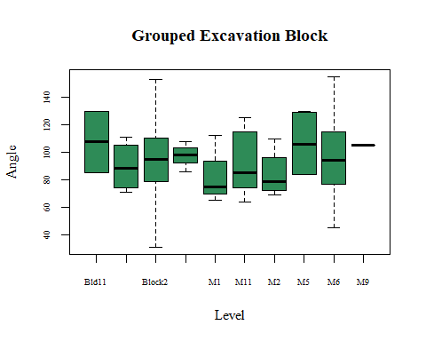Index A

Figure 1

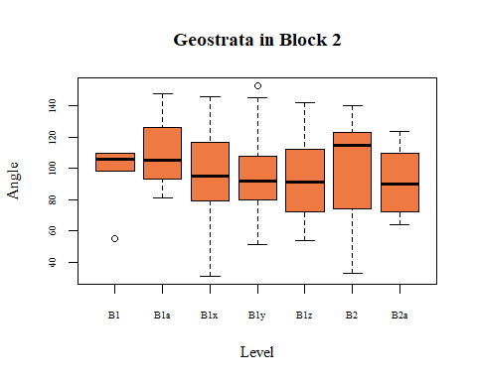

Figure 2

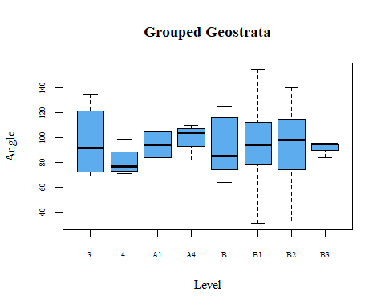

Figure 3

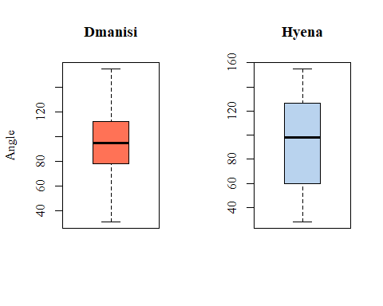

Figure 4

Partial Data use from Coil et al., 2017

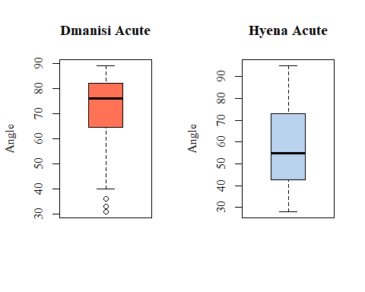

Figure 5

Partial Data use from Coil et al., 2017

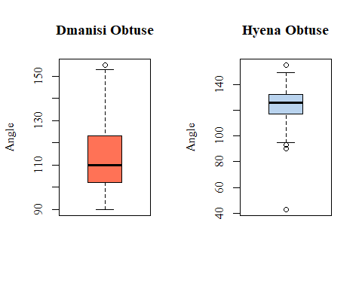

Figure 6

Partial Data use from Coil et al., 2017

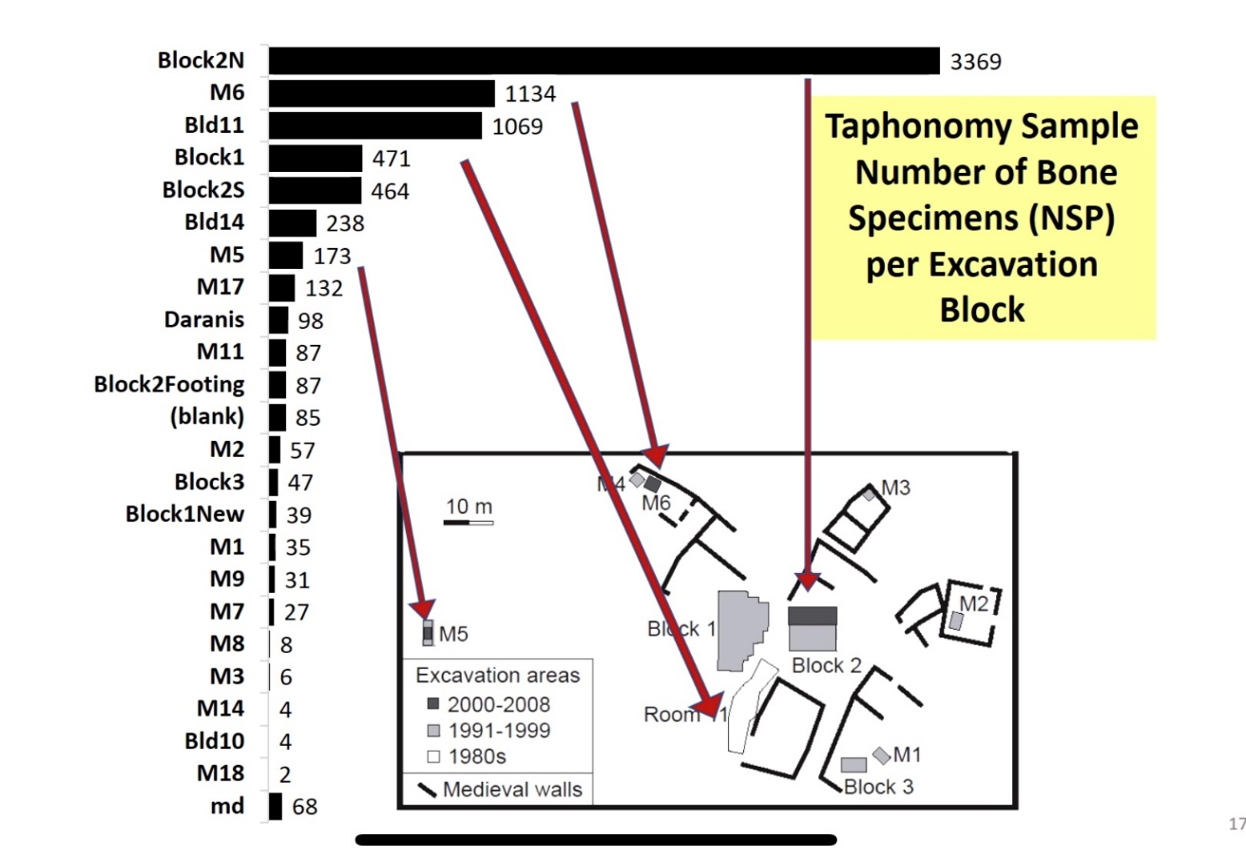Index B

Figure 1

Tappen et al., Press

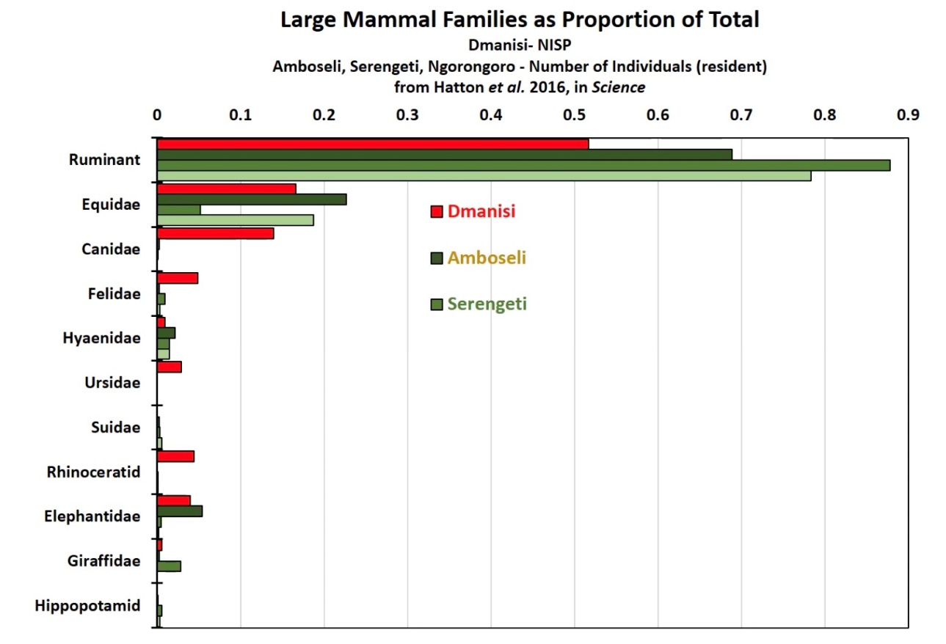

Figure 2

Tappen et al., Press

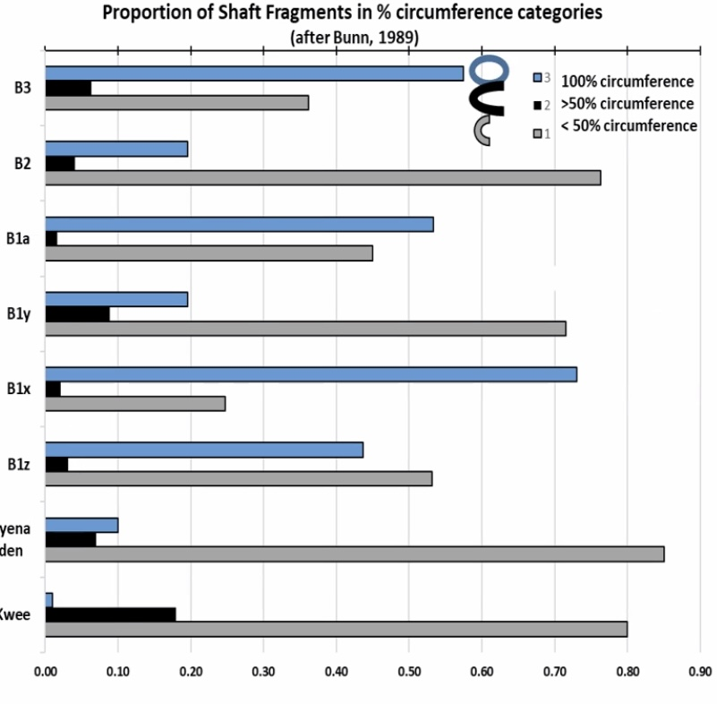

Figure 3

Tappen et al., Press

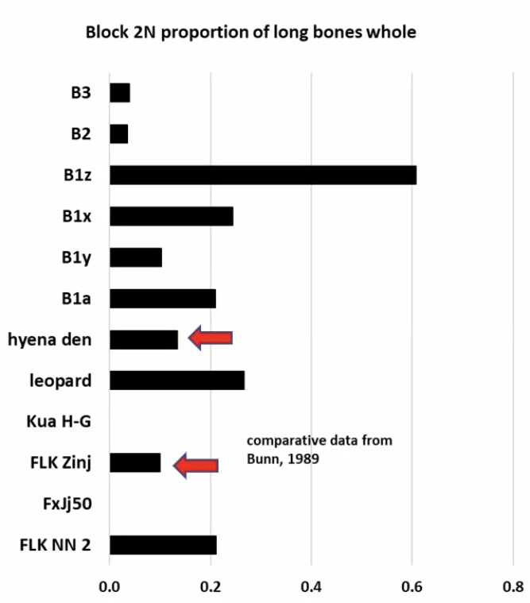

Figure 4

Tappen et al., Press

References

Bartolini-Lucenti, S., Cirilli, O., Pandolfi, L., Bernor, R.L., Bukhsianidze, M., Carotenuto, F.,

Lordkipanidze, D., Tsikaridze, N., Rook, L., 2022. Zoogeographic significance of

Dmanisi large mammal assemblage. Journal of Human Evolution 163.

Behrensmeyer, A. K., 1978. Taphonomic and ecologic information from bone weathering.

Paleobiology 4:2, 154.

Coil, R., 2016. Spatial approaches to site formation and carnivore-hominin interaction at

Dmanisi, Georgia. Ph.D. Dissertation, University of Minnesota.

Coil, R., Tappen, M., Yezzi-Woodley, K., 2017. New analytical methods for comparing bone

fracture angles: a controlled study of hammerstone and hyena (*Crocuta Crocuta*) long

bone breakage. Archaeometry 59, 900-917.

Coil, R., Tappen, M., Ferring, R., Bukhsianidze, M., Nioradze, M., Lorkipanidze, D., 2020.

Spatial patterning of the archaeological and paleontological assemblage at Dmanisi,

Georgia: an analysis of site formation and carnivore-hominin interaction in Block 2.

Journal of Human Evolution 143.

Domínguez-Rodrigo, M., 2008. Conceptual premises in experimental design and their bearing on

the use of analogy: an example from experiments on cut marks. World Archaeology, 40:1, 67-82.

Gidna, A., Yravedra, J., Domínguez-Rodrigo, M., 2013. A cautionary note on the use of captive

carnivores to model wild predator behavior: a comparison of bone modification patterns

on long bones by captive and wild lions. Journal of Archaeological Science 40, 1903-

1910.

Pickering, T.R., Domínguez-Rodrigo, M., Egeland, C.P., Brain, C.K., 2005. The contribution of

limb bone fracture patterns to reconstructing early hominid behavior at Swartkrans Cave

(South Africa): archaeological application of a new analytical method. International

Journal of Osetoarchaeology 15, 247-260.

Stewart, M., Andrieux, E., Clark-Wilson, R., Vanweezer, N., Blinkhorn, J., Armitage, S.J., al

Omari, A., Zahrani, B., Alqahtani, M., Al-Shanti, M., Zalmout, I.,Al-Mufarreh, Y.S.A., Alsharekh, A.M., Boivin, N., Petraglia, M.D., Groucutt, H.S., 2021. Taphonomy of an excavated striped hyena (*Hyaena hyaena*) den in Arabia: implications for paleoecology and prehistory. Archaeol Anthropol Sci 13**,**139. <https://doi.org/10.1007/s12520-021-01365-6>

Tappen, M. et al., Press. Journal of Human Evolution.

Villa, P., Mahieu, E., 1991. Breakage patterns of human long bones. Journal of Human Evolution

21, 27-48.